3 Idiots

**Sadman Sakib -1005**

**Bashirul Islam -1022**

**Billal Hossen Nirab -1020**

Connect 4

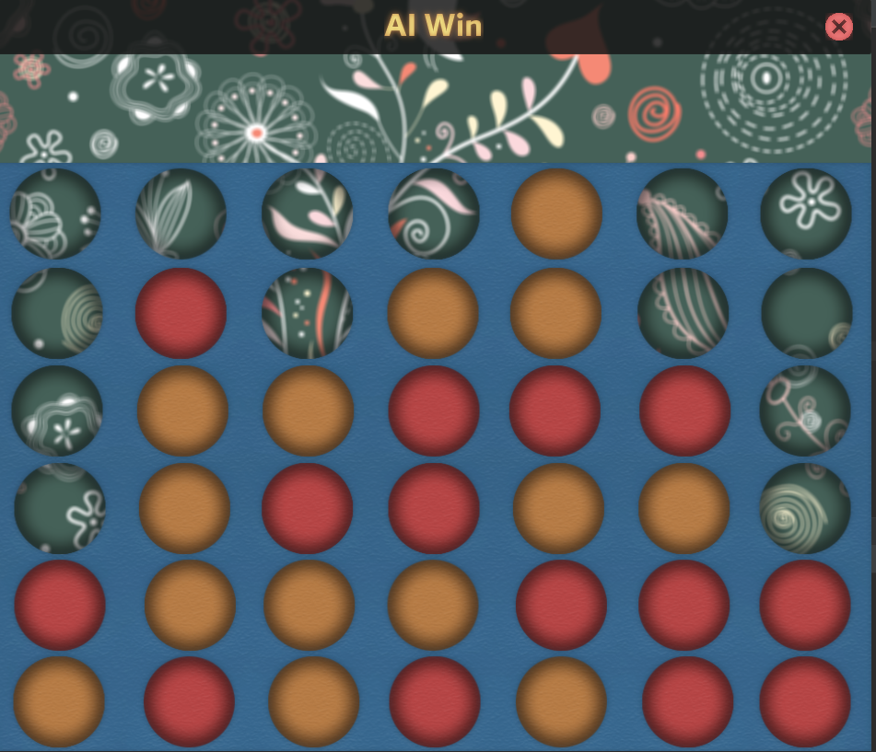

Language

* Java

Environment

* IntelliJ
* Scene Builder

Implementation

* Min max Algorithm
* Alpha beta pruning

Gitlink

https://github.com/BHN-Nirab/Connect_4_AI_Game